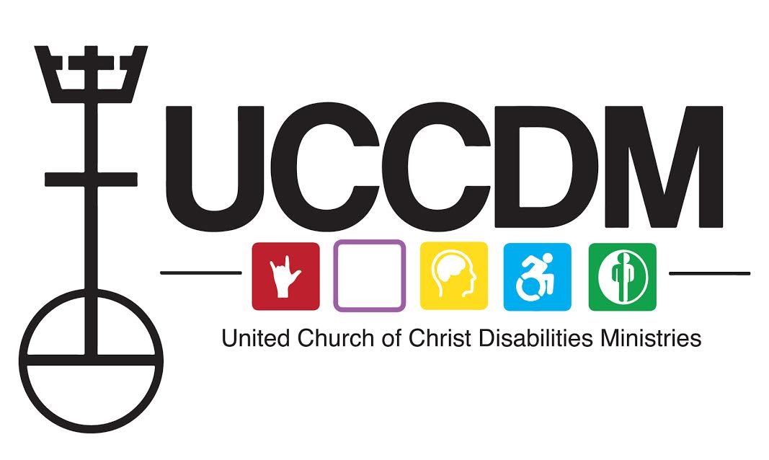
ACCESS SUNDAY

Words for Worship

CALL TO WORSHIP
Leader: We gather in the name of our God.

All: The Disabled God, the God of Access, the God of Interdependence, the God whose Differences are Holy.

Leader: How shall we worship this God?

All: With sound and with silence, with raised hands and with stillness, with words spoken and unspoken, with deep thought and the inner movements of our souls.

Leader: With every limit and ability of our bodies and minds, we will worship God.

All: Praise be to God.

CALL TO CONFESSION
All: Merciful God, we come before you today as people who are worried about those who are oppressed, marginalized, and forgotten. We confess that sometimes we forget about those made in your image. We confess that we do not speak up when people declare who can be the insiders in our church and our community. Forgive us and create in us a way to keep our hearts, minds, and doors wide open with love and understanding. Help us reach out beyond ourselves and learn about the joys of all the communities. Give us the patience to learn that all people have gifts and abilities to share with our community of faith. We pray in Jesus’ name. Amen.

ASSURANCE
Leader: People of God, the grace of the Divine is wide and deep enough for us all. Shed any guilt or shame that holds you back from authentic, loving connections with others. Do not be afraid of your humanity, even when being human means making mistakes. For you are loved more deeply than you can imagine, and there is nothing that can separate you from that love. Amen.

TITHES AND OFFERINGS

INVITATION
We come now to the time for receiving an offering. Traditionally on Access Sunday, we would ask you to give to the UCC Disabilities Ministries Board, or to the Virginia Cryer Scholarship, and while we certainly encourage you to do that, we also invite you to use this as a moment to go to your church, and examine your church budget. Most churches have budgets for ongoing maintenance, and many have budget for capital improvements—but do you have a budget for accessibility improvements? Budgets are moral documents; they show us where our priorities are. If you wish to commit to accessibility, advocate with your church to add an accessibility improvements line item to the budget, for this year and all years to come. And take an offering today to put towards those accessibility improvements.

PRAYER OF DEDICATION
Let us pray.

God of abundance, we believe that there is enough for all, so long as we share what we have. Bless our generosity with justice, access, and a community where all can bring their gifts to the table. In your holy name we pray: amen.

SCRIPTURE
Mark 10:17-31

CHILDREN’S TIME
Note: There are going to be those who think that we’re saying that people with disabilities are children, and that’s not what this is about. We are saying that children are uniquely positioned to understand what it’s like to live in a world that is not designed for them.

Have you ever had an experience that was made more difficult for you as a kid because something was grown-up size?

:::Use an experience of your own you can recall, or feel free to use the following example:::

There was a six-year-old who went to the dentist—and when I say dentist, I mean she went to the grown up dentist. Even though the dentist was really nice, their office is set up for, well, grown-ups.

And all of that was fine and dandy until this six-year-old had to sit in the chair. As she shimmied up onto it, it became clear that her six-year-old body was going to have to do a lot of extra work to stay in place with her head up on the headrest. In fact, her whole body was about the same size as the top portion of the chair. Her mom had to prop her up with her purse at the part where the chair bent to keep her from sliding down as the dentist worked. She was already nervous about having a cavity filled, and not having a space where she could sit without sliding down made it even more nerve wracking.

The world is simply designed with grown up bodies as the standard, and kids have to either find ways around it--like grabbing a step stool to get to the cookies mom thought she was clever enough to hide behind the whole wheat crackers on the shelf, or, in this case, this girl ended up at a dentist made for kids—and her grown-ups saw the difference in the bill at the end, because there is usually a pretty decent mark-up on things that exist in order to provide a special service outside the norm.

It’s this reason, though, that I think that kids totally get why it is so important for us to have spaces that are fully accessible. When the world seems to be made to fit someone else, it feels like we’re being left out. It really stinks. And even though sometimes we can work around it, it gets really old—not to mention uncomfortable—having to be propped up on a dental chair by mom’s bag after a while when it would have been awesome to have a chair that would have been just right the first time. When we think about the way our churches are built, oftentimes they weren’t designed with disabilities in mind--especially some of our older churches.

Usually, churches are able to come up with a quick fix to accommodate someone on the spot, but often that feels just as awkward as being propped up on a dentist’s chair by mom’s purse.

When churches decide to become Accessible to All (A2A) They commit to making sure that everyone who comes into a church feels like it fits just right, and this means work on the physical buildings to make sure that everyone has access, but these churches also work on making sure everyone feels welcome, too! When we think about making spaces accessible to all, we make them better for every single person who comes in. My hope this morning is that you, our awesome young folks, will start thinking about what accessibility means to you and how you can help your church become accessible to all. Ask the questions, start some conversations!

Prayers of The People
Now is the time when we come together as the church to lift up prayers on behalf of our communities. On this Access Sunday, we will lift up both the sorrows and the joys of disabled communities. When you hear "GOD, in your mercy," the response is, "Be with us."

God who shows up wherever we are, we pray for access. May every mountain be leveled into a ramp, every valley raised into an elevator. May ASL, audible crosswalks, communication badges, mobility aids, and accessible public transit become like the air we breathe: abundant and nourishing. May the hearts and minds of all people be opened to consider ways of learning, knowing, and communicating that are not their own, and may we seek understanding through love. We pray for all disabled people who are denied the access tools, supports, and technologies that would lead to the full and enriched lives we deserve. Remind us, o God, that though society neglects us, you do not. God, in your mercy: be with us.

We pray for all those effected by Covid19: those who are sick, or suffering the effects of long Covid; those who have lost loved ones and community members; and all whose lives and livelihoods have been impacted in a myriad of ways. We pray especially for disabled people, O God, as we struggle to receive equal access to healthcare, to convince our communities to keep us safe, and to maintain the access and supports we need in a changing world. May your loving presence ease suffering, anxiety, and loneliness. God, in your mercy: be with us.

God, we find your Divine Image in the diversity of your people. Help us to honor that Divine Image in all those who are marginalized: BIPOC communities, queer and trans people, immigrants and refugees, those who are experiencing poverty or homelessness. We pray especially for disabled members of these groups, knowing that our disability community is wide and diverse, and that any form of oppression increases the force of ableism. We strive for solidarity between movements, in hopes of a day when justice will roll down like waters, and all oppression will cease. God, in your mercy: be with us.

God of abundant love, we thank you for the joys of community: the meals lovingly prepared with everyone's dietary needs in mind; the friends who provide image descriptions while watching movies; the Zoom gatherings full of laughter and comfort and closed captioning. Even when physically separated, O God, we rejoice in the power of community, and all it can do to sustain us. May all who are isolated be enfolded in the embrace of people who love them. May all of us who have felt distanced from our community reach out to strengthen those ties again. God, in your mercy: be with us.

God of interdependence, we rejoice in solidarity: across disability, across marginalization, across all that seeks to divide us from loving our neighbor. We know that what harms one of us harms all of us, and that none can be free until all are free. Be present with us when we remember this, in advocating for the needs and rights of another; and be present, and remind us, when we forget it, when fear and comfort tempt us to put our privilege above another's need. Recall to us the joy of relying on one another and being relied upon, of being one body, and call us to love. God, in your mercy: be with us.

God of infinite resourcefulness, we thank you for the myriad ways of living life, all the different ways in which we can speak, read, move, work, play, and love. You did not intend for there to be only one way of being human, but instead created many kinds of bodyminds, and many ways to use them. We honor our disabled ancestors and elders, who taught us their tips and tricks: how to use our canes and wheelchairs, what tools and toys work best in our hands, what movements cause the least pain, and that different ways of thinking are not wrong ways of thinking. At the same time, we pray for all those who feel trapped or hampered by their bodies and minds. We validate their pain and frustration and pray for it to be eased, even as we pray that they may know blessings from their bodyminds. God, in your mercy: be with us.

We commit these prayers to you O God, those spoken aloud and those communicated to you in any other way. We pray now together, inspired by the words of Jesus, saying,

THE LORD’S PRAYER, REIMAGINED
Our God who is disabled, holy are your differences.
May your work of inclusion be done, on earth as it is in heaven.
Grant us access in all the ways we need.
And forgive us for excluding others, as we forgive those who exclude us.
Keep us away from the temptation of believing we’re not enough,
and deliver us from the evils of ableism.
God, in you we find community, welcome, and belonging;
now and forever. Amen.

MESSAGE
We invite you to use the conversation among our Disability Theology Working Group as you prepare your own message for this Sunday as we reflect on Mark 10:17-31 with a disability lens, or, for those who are engaging in virtual or hybrid worship, feel free to use our conversation as the message for this week.

BENEDICTION
As you leave this space remember that everyone you encounter is made in the image of God. Embrace your own differences, celebrate the differences of others, and proclaim the Good News that God’s love does not fit into a tiny box, but it is without boundary. It extends to all. Go in peace. And let all the people say, Amen.

